Program Management Manager, Empowerly
Gelyna Price (guh-LEE-nah) & Hanmei Wu

Research:

Company culture:
Our Values
● Be Empowered: Dive in and own your impact. Proactively seek solutions and
drive results that get the job done well and on time, every time—communicating
in moments when deadlines need to be pushed or support is requested.
● Be Collaborative: We accomplish more together than we would apart. By being
transparent, sharing ideas, offering honest feedback, growing from our mistakes,
and leveraging each individual’s unique strengths, we tackle challenges as a
team.
● Be Adaptive: Navigate challenges with resourceful resilience. Expect and
embrace evolving situations, find creative ways forward, persist through
difficulties, and leverage available resources to achieve our common goals.
● Act with Urgent Curiosity: We approach every challenge and rapid change with an
open mind and a desire to learn, moving quickly and with purpose every time.
● Lead with Humble Respect: Value contributions and new ideas from all teammates,
regardless of status, by cultivating a culture where empathy and understanding
pave the way for all to shine.
● Make the Student the Hero: We put our students and families first, always. We are
their champions every step of the way. Their satisfaction and su

Org & Department:
- The Empowerly Score®: a data-driven tool that evaluates college application readiness across academics, extracurriculars, essays, and more
- Services:
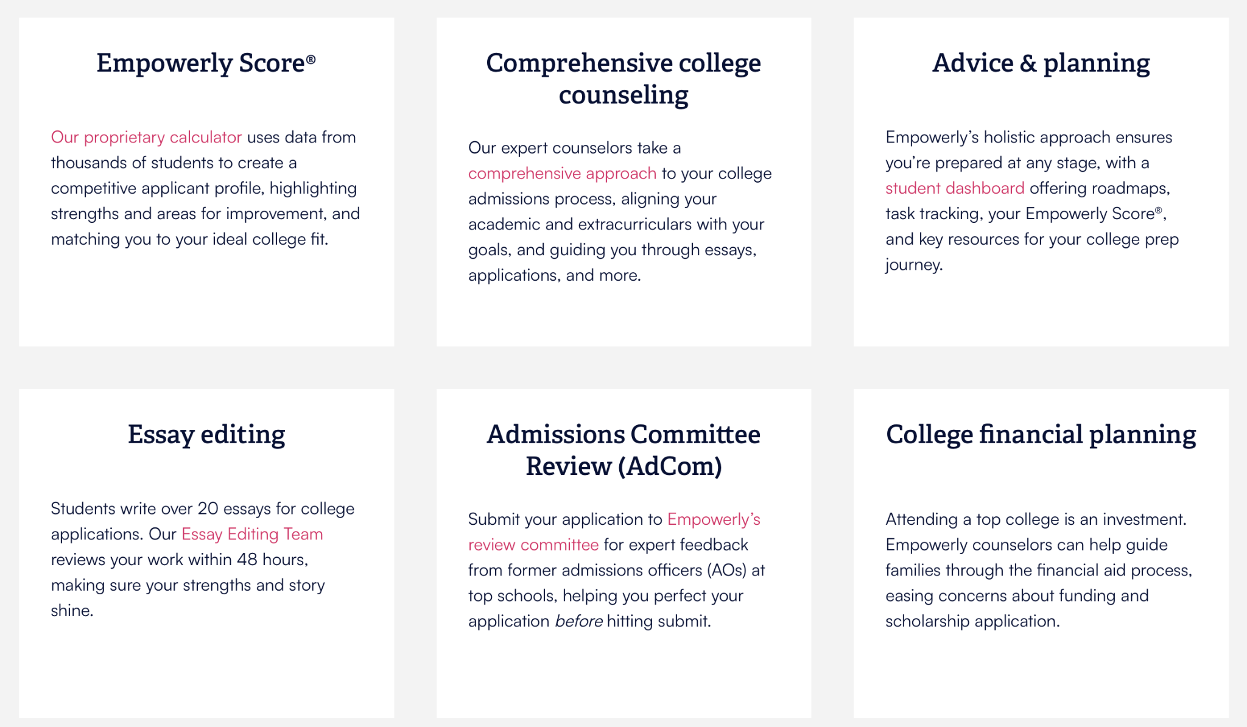
Core requirement:
How?
- Recruit, onboard, and manage startups and mentors for the programs
- Manage programs team and contractor teams who will help maintain program relationships and interact with students (?)
What?
- In house ancillary programs + research + internship programs
- Internal training materials
- quality controls metrics and assessments

AI project; research; mentorship

Intro & examples:
- Currently, I serve as a Program Enablement Manager where I collaborate with global vendors and cross-functional teams to manage over 20 educational programs
- Past 3 years:
  - BD: client facing roles
  - Partners and clients in China
  - 7-8 years in College counseling as a past mentor myself

- I describe myself as a data-driven program manager with a master’s in Organizational Psychology and work experience in the people space.

- What’s unique about my approach is that I bring my background in psychology—specifically in needs assessments, feedback collection, and data analytics—to refine learning design and outcomes.

- In the past, I’ve worked in various types of organizations across many fields, including medical technology, fintech startup, as well as renewable energy multinational company.

- In these roles, I’ve also managed global initiatives like designing a DEI workshop that was later scaled to 23 global locations, as well as a self-started project where I translated 2,000+ employee survey responses into insights that informed L&D strategy for a leadership team.

- When I first learned about the program manager opportunity at Empowerly, I’m truly excited about this role because it sits at the given company's focus on technology and data — which aligns closely with my belief in data-driven decisions and approaches.

Examples:

Ambiguity into structured:
- Situation/Context:
  - Responsible for launching new programs at IGP
- Task/Conflict:
  - A few counselor and sales teams going through transitions; unclear responsibilities each team owes
- Action:
  - Reached out to a few leaders to address this issue by setting up an onboarding protocol guide
  - step by step and line by line
  - clarity who’s responsible for what step
- Result:
  - Reduce onboarding time by 75% (with significant less email inquiries)

Training experience:
- Situation/Context:
  - New ancillary programs
- Task/Conflict:
  - Timeline → for student and parent facing counselors
- Action:
  - Develop documents providing all competition timelines, host live webinars, engage partners to educate relevant teams
- Result:
  - 600+ participants,
  - enhancing program understanding and driving a 78% client conversion rate

Problem Solving:
- Situation/Context:
  - I source and collaborate with vendors for some programs
- Task/Conflict:
  - student engagement issue while working on their team projects
  - Difference in client vs vendor expectations
- Action:
  - Set up semi-structured interviewed the students and counselors personally
  - Discuss and brief feedback with vendor to discuss change plans
- Result:
  - A stronger curriculum design better aligned with student needs with higher satisfaction rates from the students indicated by the surveys

Cross-functional collaboration/Vendor relationship:
- Situation/Context:
  - Roll out new programs with marketing team’s support
- Task/Conflict:
  - Packed marketing schedule;
- Action:
  - Hop onto a call to address their concern and discuss what other space we can utilize
- Result:
  - 1 podcast episode, 2 webinars, and newsletter features

Vendor relationship:
- Talk about asking the right questions and their needs
- The value of virtual face time
- AoPS:
  - Point out the elephant in the room
  - Relate and address

Metrics (how to ensure quality):
- Situation/Context:
  - New program that require results to best sell
- Task/Conflict:

- Action:
  - Survey and student rating
- Result:
  - New flyers with student testimonials
  - See two times in the second cohort

Prioritization, wear different hats, work style:
- Situation/Context:
  - Event planning, program management, promotional efforts, partnership management, etc.
- Task/Conflict:
  - Lots of details
- Action:
  - Organizational skills:
    - No brainer
    - Daily tasks
- Result:
  - Never miss a deadline
  - Score 5/5 for performance review for punctuality and meeting deadlines; best employee of the year in 2025

Strength:
- Situation/Context:
  - Relying on data to solve program and create sustainable strategy based on customer needs
- Task/Conflict:

- Action:

- Result:

Weakness:
- Situation/Context:
  - Resolve issue around student engagement for a program
- Task/Conflict:
  - Consume more time
- Action:
  - Buy time from the vendor
- Result:
  - Resolve the root cause issue, creating more long term sustainable outcome

Questions:
Team org:
- How will the role fit into the larger Empowerly team? Will there be any immediate teammates?
  - 3 other program managers
    - Managing the one person who’s running the internship program
  - 2 other program managers:
    - Running partnership with library patrons
    - Would be invited to product team meetings with the two other managers
  - Regular meetings with product

- # of full time vs part time employees? 80~90; 150 counselors + 20
- “Manage programs team and contractor teams who will help maintain program relationships and interact with students”?
  - Main point of contact; trouble with certain situations around programs; won’t be recruiting them

Learning Programs:
- “we’re looking to grow our revenue by 150–200%+ in the coming phase”
  - What are some biggest challenges and growth areas?
    - Lots of customers, but haven’t purchased or heard from ancillary programs

  - What does 'success' look like for this role in the first 3 months?
    - Automated (a data scientist); someone else who creates AI bot
    - Large scale brainstorming

- In my program management experience, I learned the value of insight-driven strategy and decision making. Empowerly seeking fast growth, I'm interested in how you balance quick decision-making against the deeper analysis needed to build sustainable, high-quality programs?
  - Saw that she had some background in research, including some data-driven research and creating satisfaction questionnaire for diabetes study
- Chinese speaking skill & WeChat
  - Not really
- “Moving Research program in house”?

Other questions:
- Preferred start date?
- What would training and learning look like for this role, including any Professional Development resources?
  - What would the career path look like for this role?
- How does Empowerly, as a remote-first company, foster community and social interaction in a fully remote environment?
  - Annual conference in April (every year there would be in person retreat)
  - Offsite events? Team building?
- How would you describe your management style?

About the job
About Empowerly
Empowerly is a fast-growing ed-tech company on a mission to empower students to become the most successful version of themselves. Our platform combines expert college counseling with proprietary tools like the Empowerly Score™, offering families a 360° view of their child’s college readiness across academics, essays, and extracurriculars.
We’ve raised $30 million from top-tier investors including Goodwater Capital, Conductive Ventures, FJ Labs, Scrum Ventures, Translink Capital, Azure Capital Partners, and Spero Ventures.
Empowerly is a founder-led company that has grown through SEO-driven performance marketing. We’ve now invested heavily in scaling a diversified GTM motion across Sales, Events, B2C, Partnerships, and Business Development and we’re looking to grow our revenue by 150–200%+ in the coming phase. This role will be critical to helping us make that leap.
We operate on a remote-first basis, building a team of individuals who excel in remote environments and are passionate about making high-quality college counseling accessible to all students, regardless of their background or location.
The Role
- Empowerly offers in-house ancillary programs and partnerships with services such as summer programs, research internships, tutoring programs, and more
- The Program Manager will lead the Operations Support behind Empowerly’s ancillary programs and partnerships. You will wear many hats, make quick decisions, and create processes from ambiguity. You aren’t afraid to dig in the weeds and use data to come up with solutions to complex problems.
- The Program Manager will work cross functionally with Marketing, Sales, Product, and Engineering to create and refine processes, build automations, and scale these partnership programs to accommodate thousands of students.
Responsibilities

- Lead and implement all ancillary Empowerly programs as service offerings grow
- Act as the liaison between Empowerly and 2+ partnership programs that Empowerly students work with
- Manage programs team and contractor teams who will help maintain program relationships and interact with students
- Own the end-to-end process of bringing the Research Scholars Program in house, including mentor sourcing and onboarding, program structure, and quality control
- Recruit, onboard, and manage startup companies participating in the Startup Internship Program
- Manage both short term and long term operational strategy and proactively anticipate the needs of our programs as our student base grows exponentially
- Ensure overall program health, including establishing internal quality controls metrics and assessments, bench analysis and expansion, and alignment with company priorities.
- Provide regular data reporting, sharing insights on the programs’ success rates and outputs
- Source, vet, and onboard new programs
- Design, present, and implement training resources for counselors to share services with existing students and help onboard them to new programs.
- Work closely with Marketing and Sales Teams to create training documentation on how to speak about Empowerly ancillary programs and attract new students and families.
Who You Are

- Bachelor Science or Bachelor of Arts
- 3+ years of experience in Program or Project Management
- 2+ years of management experience
- Experience with all Google tools, including Google Sheets and Google Drive
- Experience in data analysis and creation of performance dashboards
- Highly structured and organized thinker
- Willingness to engage and learn
- Tech savvy
- Experience working with or at startups
- Experience working in EdTech
- Familiarity with education technology industry and the challenges and demands it places on leaders and teams
- Experience with Airtable, WorkRamp, and Zendesk are a plus
A great deal of your fulfillment at any company is determined by the extent to which the values of the people and the organization align with your own. It’s hard to assess culture from the outside and most companies are not good at describing their own nature. (How do fish describe water?) They also have incentives to say things that sound attractive rather than things that are true.

We’ve tried to assemble characteristics. This is our best attempt to share an honest description of our culture today. We hope you find it useful in deciding whether Empowerly is the kind of place in which you’d like to spend your time.

We may use artificial intelligence (AI) tools to support parts of the hiring process, such as reviewing applications, analyzing resumes, or assessing responses. These tools assist our recruitment team but do not replace human judgment. Final hiring decisions are ultimately made by humans. If you would like more information about how your data is processed, please contact us.

This is an exciting opportunity, Jamie. Empowerly is in a "scaling" phase, moving from a small startup to a much larger operation aiming for 150–200%+ growth. Since you are interviewing with the Chief of Staff, they will be looking for someone who can turn "ambiguity" into a structured process that works at a large scale.

1. Company Research: What You Need to Know
- The Mission: Empowerly combines human expertise (counselors) with a tech platform (Empowerly Score™) to help students with college readiness.
- The Growth: They have raised $30 million from top investors like Goodwater Capital. They are currently shifting from purely marketing-driven growth to a "diversified GTM (Go-to-Market) motion" involving Sales and Partnerships.
- The Culture: They are remote-first. The JD includes an honest note that they are still "describing their own nature" but value people who can "make quick decisions" and aren't afraid to "dig in the weeds".
- Glassdoor Summary (Industry Context): Based on the JD's description of a "fast-growing" and "founder-led" company, common themes for firms at this stage include high autonomy, a fast pace, and the need for employees to create their own "playbooks" because processes don't always exist yet.

2. Why You Are a Strong Fit
You can map your specific achievements directly to the "Who You Are" and "Responsibilities" sections of the JD:
- Scaling and Efficiency: The JD asks for someone to "scale partnership programs to accommodate thousands of students". You have already reduced onboarding time by 75% for over 70 staff members, which is exactly the kind of efficiency they need.
- Data-Driven Decisions: They need a manager who can provide "regular data reporting" and "bench analysis". Your experience analyzing 2,000+ employee responses and delivering insights to the C-suite at NextGen proves you can handle large-scale data and make it useful for leadership.
- People and Program Design: The role involves "mentor sourcing and onboarding" and "training counselors". Your M.S. in Org Psych and experience designing training for 600+ participants makes you an expert in how people learn and how to build effective support systems.
- Startup Mindset: You were named "Employee of the Year" at InGenius Prep, showing you have the "hard work and dedication" required for a high-growth startup environment.

3. Interview Preparation: Chief of Staff Focus
A Chief of Staff is usually the "fixer" for the CEO. They care about systems, scalability, and speed.
- Prepare your "Ambiguity" story: Be ready to talk about a time you were given a messy project with no instructions and how you built a step-by-step process for it. Use your HubSpot training video example as a way you scaled knowledge for the team.
- Focus on the "Research Scholars Program": This is a specific program they want to bring "in-house". Mention your Elanco research project as proof that you know how to design a study, find the right participants, and deliver a final report.
- Tech Savvy: While you haven't mentioned Airtable or Zendesk, you can highlight how quickly you mastered Genieand created training for it.

4. Questions You Should Ask
Asking the right questions shows you are already thinking like a Program Manager:
- "You mentioned bringing the Research Scholars Program in-house. What is the biggest bottleneck the team is currently facing in that transition?"
- "With a growth goal of 150–200%, what does 'success' look like for this role in the first 90 days?"
- "Empowerly is remote-first. How does the Programs team maintain quality control and mentor engagement without being in the same room?"
- "The JD mentions creating processes from ambiguity. Can you give an example of a program that currently needs a more structured workflow?"
Would you like me to help you draft a "STAR" method response for a question about handling "ambiguity" using your NextGen or InGenius Prep experience?

$85K

Report to Co-founder:
Implement training resources
